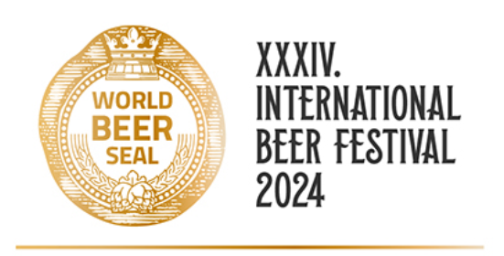

BINDING APPLICATION FORM
THE BEER SEAL TASTING COMPETITIONS 2024

Company:
Adress:
Reg. No: |  |  | VAT number:
Responsible representative:
e-mail: |  |  | Phone:

Our registered casting samples are as follows:
Trademark of product | Category
 | Select the category
 | Select the category
 | Select the category
 | Select the category
 | Select the category
 | Select the category
 | Select the category
 | Select the category

We agree with the invoice fee of 900,- CZK (30 € , 36 $) per each registered casting sample.
We are interested in participating in public presentation at the festival as a business partner. YES/NO*

Date: |  | Signature (or name):

*Delete as appropriate, if there is not enough space, use another form.

